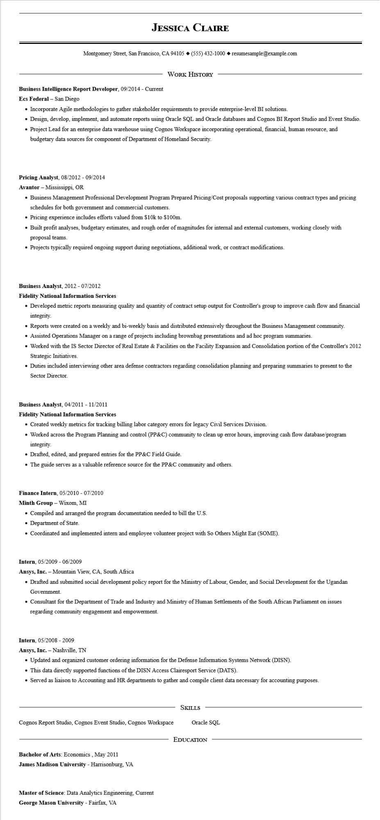
JESSICA CLAIRE
Montgomery Street, San Francisco, CA 94105 ◆ (555) 432-1000 resumesample@example.com
WORK HISTORY
Business Intelligence Report Developer, 09/2014 - Current
Ecs Federal - San Diego
• Incorporate Agile methodologies to gather stakeholder requirements to provide enterprise-level BI solutions.
• Design, develop, implement, and automate reports using Oracle SQL and Oracle databases and Cognos BI Report Studio and Event Studio.
• Project Lead for an enterprise data warehouse using Cognos Workspace incorporating operational, financial, human resource, and
budgetary data sources for component of Department of Homeland Security.
Pricing Analyst, 08/2012-09/2014
Avantor - Mississippi, OR
• Business Management Professional Development Program Prepared Pricing/Cost proposals supporting various contract types and pricing schedules for both government and commercial customers.
• Pricing experience includes efforts valued from $10k to $100m.
• Built profit analyses, budgetary estimates, and rough order of magnitudes for internal and external customers, working closely with proposal teams.
• Projects typically required ongoing support during negotiations, additional work, or contract modifications.
Business Analyst, 2012 - 07/2012
Fidelity National Information Services
• Developed metric reports measuring quality and quantity of contract setup output for Controller's group to improve cash flow and financial integrity.
• Reports were created on a weekly and bi-weekly basis and distributed extensively throughout the Business Management community.
• Assisted Operations Manager on a range of projects including brownbag presentations and ad hoc program summaries.
• Worked with the IS Sector Director of Real Estate & Facilities on the Facility Expansion and Consolidation portion of the Controller's 2012 Strategic Initiatives.
• Duties included interviewing other area defense contractors regarding consolidation planning and preparing summaries to present to the Sector Director.
Business Analyst, 04/2011 - 11/2011
Fidelity National Information Services
• Created weekly metrics for tracking billing labor category errors for legacy Civil Services Division.
• Worked across the Program Planning and control (PP&C) community to clean up error hours, improving cash flow database/program integrity.
• Drafted, edited, and prepared entries for the PP&C Field Guide.
• The guide serves as a valuable reference source for the PP&C community and others.
Finance Intern, 05/2010 - 07/2010
Minth Group - Wixom, MI
• Compiled and arranged the program documentation needed to bill the U.S.
• Department of State.
• Coordinated and implemented intern and employee volunteer project with So Others Might Eat (SOME).
Intern, 05/2009 - 06/2009
Ansys, Inc. - Mountain View, CA, South Africa.
• Drafted and submitted social development policy report for the Ministry of Labour, Gender, and Social Development for the Ugandan Government.
• Consultant for the Department of Trade and Industry and Ministry of Human Settlements of the South African Parliament on issues regarding community engagement and empowerment.
Intern, 05/2008 - 2009
Ansys, Inc. Nashville, TN
• Updated and organized customer ordering information for the Defense Information Systems Network (DISN).
• This data directly supported functions of the DISN Access Clairesport Service (DATS).
• Served as liaison to Accounting and HR departments to gather and compile client data necessary for accounting purposes.
Cognos Report Studio, Cognos Event Studio, Cognos Workspace
Bachelor of Arts: Economics, May 2011
James Madison University - Harrisonburg, VA
Master of Science: Data Analytics Engineering, Current George Mason University - Fairfax, VA
SKILLS
Oracle SQL
EDUCATION

